INFO2222 - Usability and Security

School of Computer Science

Group Project - Project Phase 2

Please use this template to answer your project phase 2. Do not change the titles of the questions; just answer below the title. Each task of the question should start on a new page. If necessary, you can take more than 1 page to answer the questions, but please start each question on a new page.

Do not edit the first page of the template except for entering your name and SID below.

Group Name (as it appears in Canvas) | PRJ-T02-G04
Tutorial Number | 02
Student 1 - Name: | Seonghyun Kim
Student 1 - SID: | 520000870
Student 2 - Name: | Adam Li
Student 2 - SID: | 550231811
Student 3 - Name: | Jimu Li
Student 3 - SID: | 540735585
Student 4 - Name: | Christina Liu
Student 4 - SID: | 550732385

Task 1-a
- The goal and a brief description of the interview (~ 50 words)
The aim of this interview is to understand the challenges that university students are facing in group work including communication, coordination, and task management. The interview aims to build an effective group collaboration system to solve their common issues.

- Who the potential participants are, along with inclusion/exclusion criteria (~ 50 words)
The potential participants are university students who have recent experience in group assignments. Inclusion criteria include currently enrolled university students and students who have experience in at least one group project. Students who have no group work experience before and who are not currently enrolled in a university are excluded.

- Plans for pilot studies and ethical considerations (including required ethics documents as an appendix)
A pilot interview will be conducted with one participant for the clarity. The interviewer must inform participants about the purpose of the study. Personal information will not be collected, and all responses will remain anonymous. A consent form will be included in the appendix.

- Planned activities (Refer to slide 37 in INFO2222-W02-02-UCD Lecture slides)
This semi-structured interview will ask multiple prepared questions. The interviewer is permitted to ask extra questions for more insights. Each interview is limited to take approximately 10–15 minutes and responses will be recorded.

After collecting the data, the responses will be reviewed. Key ideas will be collected and similar responses will be grouped together to form themes. These themes will be collected to understand common issues from group work experiences.

- Interview questions

1. What tools do you currently use for group work?

2. How do you usually communicate with your group members?

3. What difficulties do you face when working in a group?

4. Can you describe a situation where group work did not go well?

5. How are tasks assigned in your group? Is this effective?

6. Have you experienced communication issues? How did they affect your work?

7. What features would improve your group work experience?

- Data to be collected, data recording formats
The data will be about participants’ responses including their experiences, challenges, and preferences in group work. Data will be recorded during the interview for accuracy.

- Analysis plan
The collected data will be analysed using thematic analysis. Common patterns will be grouped into themes. These themes will help build the design of system to address their common issues.

Task 1-b
Nothing to be written. Include the transcripts in the appendix.

Task 1-c
- Thematic Analysis Process (~100 words)
First, we conducted four interviews with people experienced in group work from a variety of backgrounds and organized the transcripts. Following that, we individually assigned codes to certain segments that we deemed important, for example, “group chat clutter”, “informal task assignment”, and “difficulty holding accountability”. Then, we collated these codes together as a group and clustered them according to overarching themes. We then discussed the validity of these themes, ensuring that each theme actually encapsulated all the codes within it and that there were no contradictions or overlaps between them. Eventually, after further refinement and analysis, we agreed upon a set of unique, relevant themes that seems to fully represent the patterns found in our interviews.

- Themes
- Ensure accessibility in communications
- Formally assign structured tasks
- Reduce communication clutter
- Incorporate features in one place
- Maintain individual accountability
- Shared availability of team members

Task 1-d
Features
Feature | Comparison to Phase 1 | Comparison to existing systems
Communication Feature: A chat function that allows both group chats and communication with individual group members. The individual, private chats would reduce group chat clutter, whilst adding connivence and easy communication for information that doesn’t require the whole group knowing. | In Phase 1, the chat function only accounted for group chats. The users would not be able to communicate individually with group members. This added feature ensures communication is more accessible as sometimes users may want to ask a certain group member a question privately. | This feature is supported by many existing systems such as Microsoft Teams and Slack. Both systems support one-on-one messaging and group chat messaging.  Additionally, they both also enable users to make multiple separate group chats as well. However, for a university group project (which usually has a maximum of 6 people), multiple different smaller 2-3 people group chats may complicate communication and increase the difficulty for all group members to always be updated and informed.
Reduce Chat Clutter Feature: To address “group chat clutter”, single word replies (yes and no) would not be able to be sent in the group chat. Instead, users must react to the message with available reactions – such as a heart, a thumbs up or a thumbs down) | This is a new feature that was not in Phase 1. It was introduced to decrease the amount of group chat clutter information by reducing the amount of redundant messages. The chat will use some sort of AI that will automatically detect when there is a question asked (usually indicated by using a question mark in the message “?”). | This feature is supported by existing systems like Slack and Microsoft Teams, as both platforms allow for emoji reactions to reduce clutter in messages and chats. However, these systems do not support a feature that actively detects when a question is asked and restricts answers to only emojis. This is a somewhat unique feature.
Add an AI summarising feature that summarises the previous messages and timestamps the messages that are irrelevant so that users can skip it. | This is also an additional feature that was not in Phase 1. It was added as AI summarization allows for effective and efficient review of key points covered in messages. It is easier to read and consume the content covered in the chats rather than reading through all the chats. This feature will be added to allow easier and more seamline communication of key points covered in chats. The timestamps allow for easy jumping to important messages. | While existing systems like Slack and Microsoft Teams and many more systems have an AI-powered summarization of chats features to help users review long conversations more effectively and efficiently. These systems do not provide summaries that have timestamps to key important information covered to allow users to skip irrelevant information and jump to key points.
Task Allocation and Tracking Feature: The ability to define each task with a priority/significance, difficulty, expected time taken to complete (and the time actually taken), and deadline. Users will also be able to allocate certain tasks to certain members, and track the completion status of the task, as well as the overall project. | This feature is mostly the same as Phase 1, just with some additional small aspects. In Phase 1, tasks could be allocated and defined by priority and deadline. However, there lacked a method to track equal task allocation amongst group members. While the aspects such as “expected time taken”, “time actually taken” were not explicitly described in Phase 1, similar features such as tracking if the task is under “to do”, “in progress” or “completed” provided similar effects. Those aspects will be kept in addition to tracking the time taken to keep members accountable and on track. An additional stage “review” will also be added to ensure the quality and standard of the task aligns with all group members. | While existing systems like Microsoft Teams (via Planner) provide task assignment, deadlines, and basic status tracking, they lack deeper accountability features. It doesn’t support structured tracking of expected vs actual time spent on tasks, nor do they ensure fair workload distribution across group members. Additionally, workflow stages are limited and cannot be easily customised (e.g. adding a “review” stage), reducing flexibility in managing collaborative tasks.
Availability Feature: Every group member must fill out their weekly availability. This information would be shared to all members via a calander timetable view. | This is a new feature that was not in Phase 1. With this added feature, it ensures group meetings can be easily scheduled. It also allows all users to hold their group members accountable – as the calander would show when certain group members may be busy. This would explain delayed responses or late completion of work, allowing for more appropriate allocation of tasks. | Although existing systems like Microsoft Teams provides shared calendars and scheduling tools that allow users to view availability and coordinate meetings, it relies on passive calendar data and doesn’t require all members to actively submit their weekly availability. This may seem like it is more simplified and easier to use, however, Teams primarily infers availability from Outlook calendar data rather than requiring structured, user-defined input. The issue with this is that many university students (target users) do not use Outlook calander. Additionally, users cannot custom categories of availability such as “preferred study time”, “uni class”, “light workload”, limiting its usability.
Easy Viewing Feature:  Have all main features to be displayed on the main screen to increase convenience and allow users to see all key/important information on the same screen. As individuals often have different preferences of what information they deem important, the main screen will be editable, to allow users to customize it according to their preferences – if the default layout is not preferred. | Although Phase 1 had this feature in some of the prototypes, it did not account for the difference in references amongst different users. Some prototypes also had too much information and features on the main screen, making it potentially overwhelming for some users. With the added ability to edit the main screen, it ensures users can tailor it to fit their needs. This ensures that all important features are in one place (such as task list, missed messages, etc.) as per the user’s preference. | Existing systems with a similar feature is Notion or ClickUp, which allow users to create highly customisable dashboards where key information such as tasks, calendars, and progress can be displayed in a single view. However, these platforms often require significant setup and can become complex or overwhelming due to the wide range of features and customisation options available. While this flexibility is powerful, it may not be suitable for simpler use cases such as university group projects.

Task 1-e (~300 words)

Jack is an undergraduate student studying in the university of Sydney, who faces group works in many of his courses. He used to manage his group work with different platforms—such as messaging apps, shared documents, and calendars—finding it disordered and inefficient, which makes him feel pressed and nervous.
Jack takes part in a new group work with our new design. After opening the app, all the key information is shown on the screen. As Jack concerns the deadline and personal assignments more, he had the contents displayed on the home screen.
At the beginning of the project, Jack created several assignments and set the priority and deadline for each assignment. He assigned one of them to his groupmate Ava. During Ava working on the assignment, the system will keep track on her working and update the status automatically. Jack can monitor overall progress in real time, avoiding the information delays common in traditional collaboration.
All groupmates have entered their available time in the system, which has been consolidated into a shared calendar view. Jack can find a time for the group meeting when everyone is available very easily.
Jack can communicate with groupmates in both group chat and individual chat. When he find others sharing messages which he agrees, he attached a heart instead of sending “Good”, which makes chat screen much more organized. Besides, he can use the AI summary feature to quickly skim through the key points; the system automatically highlights the main points of discussion and marks sections of irrelevant information that can be skipped, significantly reducing the time and effort required to read through the content.
With the help of the new design, Jack worked well with his groupmates and received a good result. He felt much easier and more found the new design organized and effective.

[New Page]
Task 2-a

- Alternative design 1
This design integrates group communication and task management on one screen. The group chat is positioned on the main screen, allowing for communications and assignment work to be done simultaneously. Also, there is a list of tasks with their respective weights, durations, and deadlines allocated. The main goal of this design is to decrease the inconvenient experience for users who must utilise various platforms for just one assignment.
This is the result of addressing certain themes from the interview such as “incorporate features in one place”, “formally assign structured tasks”, and “maintain individual accountability”. It also addresses some user concerns made aware during the interviews, such as the possibility of missing important group information or potential problems with task distribution. The interface allows for an efficient workflow by ensuring group members are aware of the tasks at hand and by making the assignment progression very evident. All while having convenient and nearby communication outlets for the group members to use. By placing the task board next to the communication platform where everyone can see, this design aims to streamline group work while maintaining a high level of quality and accountability.

- Alternative design 2
This design mimics the Kanban Board format which divides the screen into four stages visually: ‘To Do’, ‘In Progress’, ‘Review’, ’Completed’. Each task is depicted as a card, and it can be moved to the next stage following its progress. Also, the user is able to attach durations, weightings, and different coloured icons to each task to distinguish who each task belongs to. There is also a communication system built into the platform, but on a different page. You would be able to go between the two pages by swiping or using icons at the bottom of the screen, much like modern communication platforms.
This design focuses on the themes: “formally assign structured tasks”, “reduce communication clutter”, and maintain individual accountability”. This method is focused on helping users to understand the state of progress efficiently. It also helps users to share each team member’s progress by specifying workflows visually and giving feedback when they confront unpredictable circumstances. In addition, each task can be highlighted based on its level of significance and group members can easily communicate in respect to the distribution of different levels of tasks and hold each other accountable for task progression.

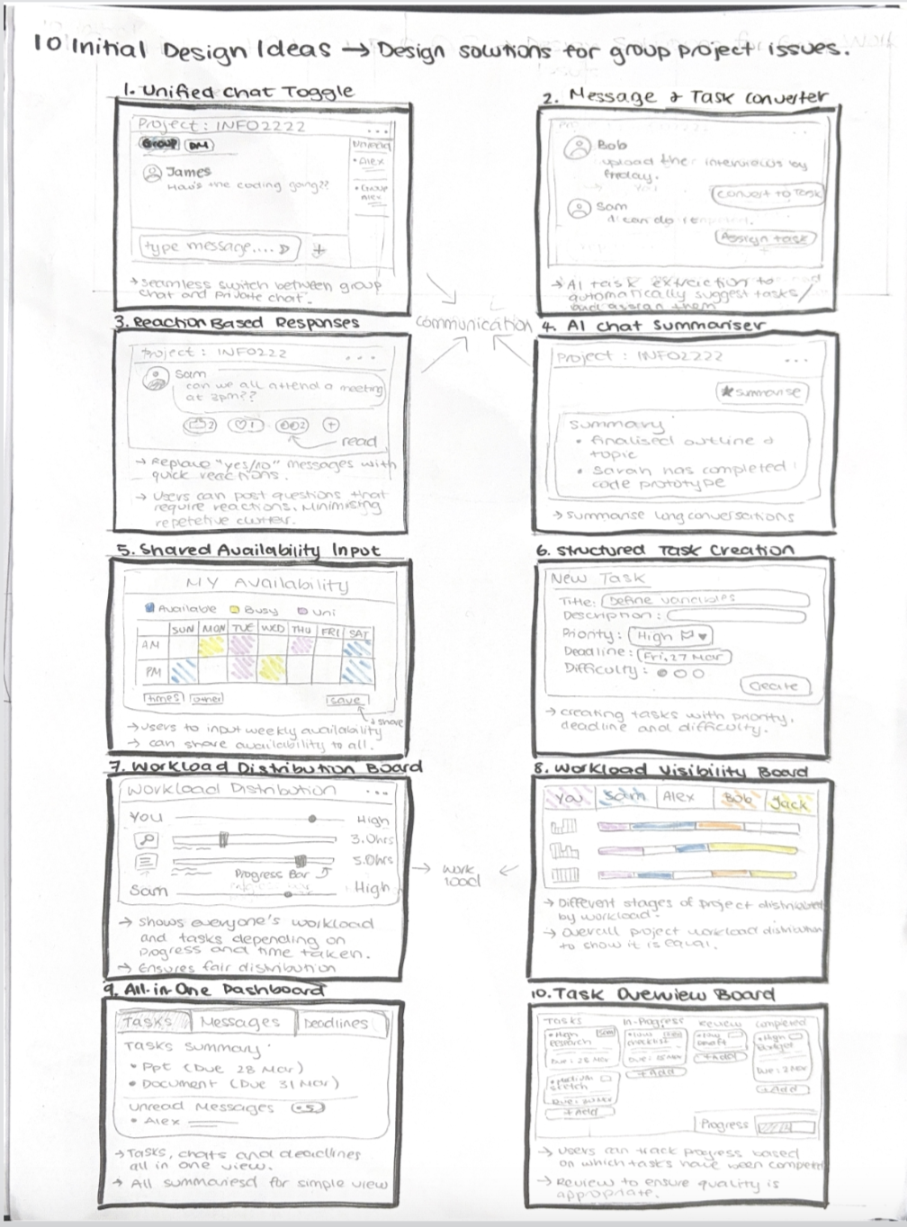
Fig. 1 10 initial design ideas

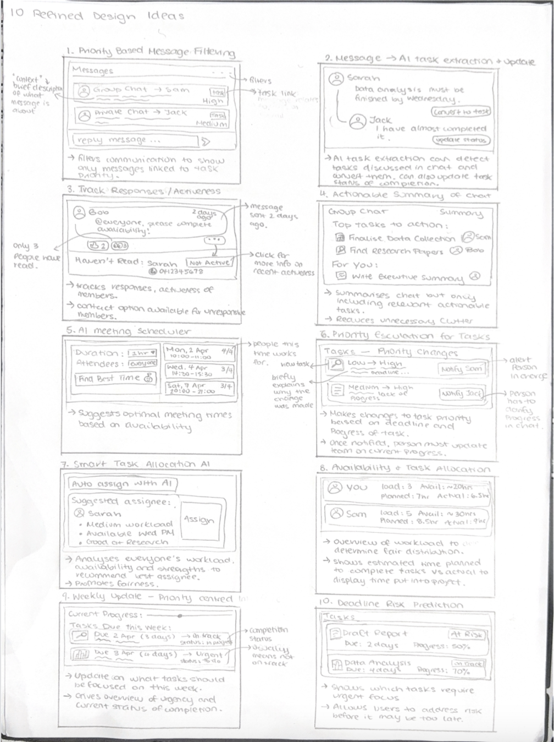
Fig. 2 10 reined design ideas.

Task 2-b (Images of your paper protypes with a short caption)

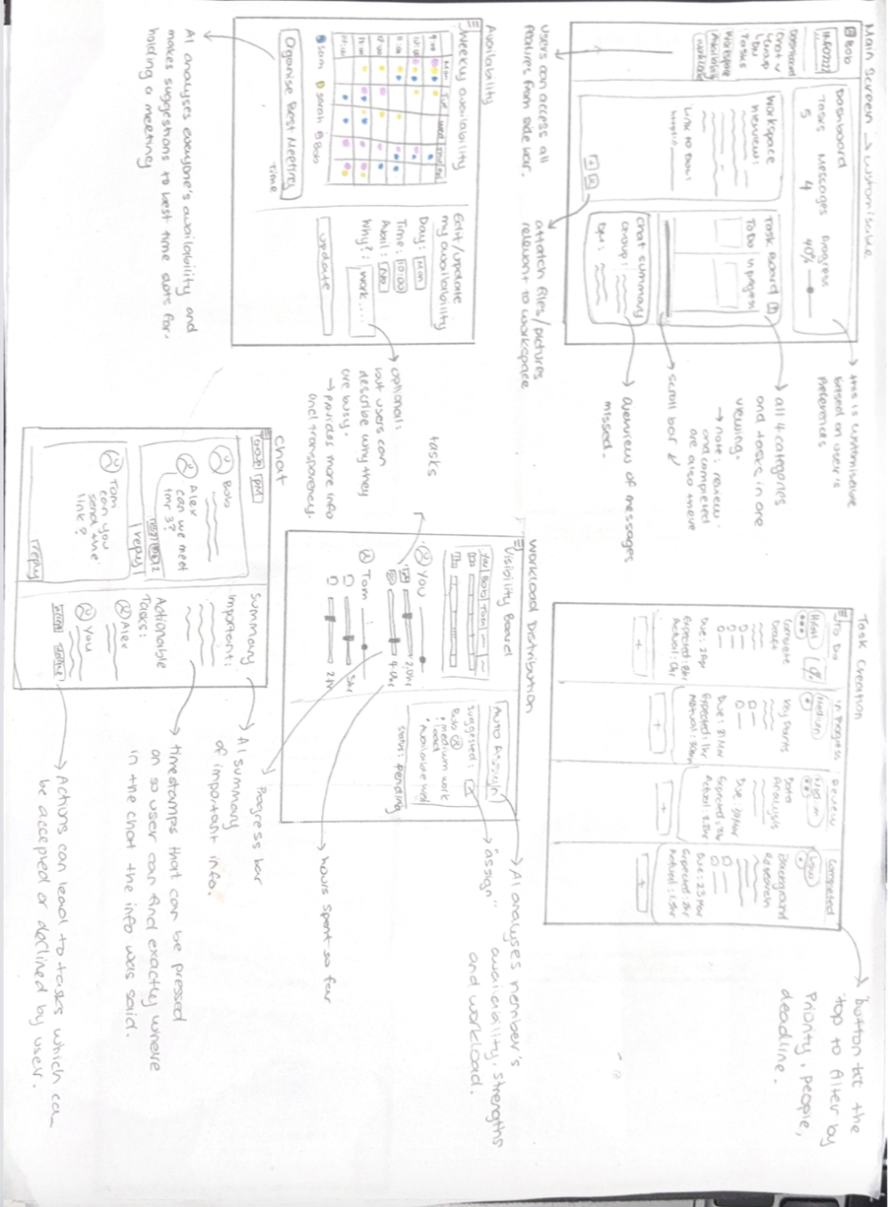

Figure 3: Horizontal Paper Prototype

This paper prototype displaces all the pages/screens our solution would offer. With visual representations for the main screen, availability screen, task distribution screen, the workload screen and the chat screen. Each page has annotations related to features that were added to the page. Most of the features from the ideation (10 by 10) stage were incorporated to maximise the usefulness of the solution. All the features chosen were based on the main concerns of the interviewees, addressing those concerns and providing a potential solution to them.

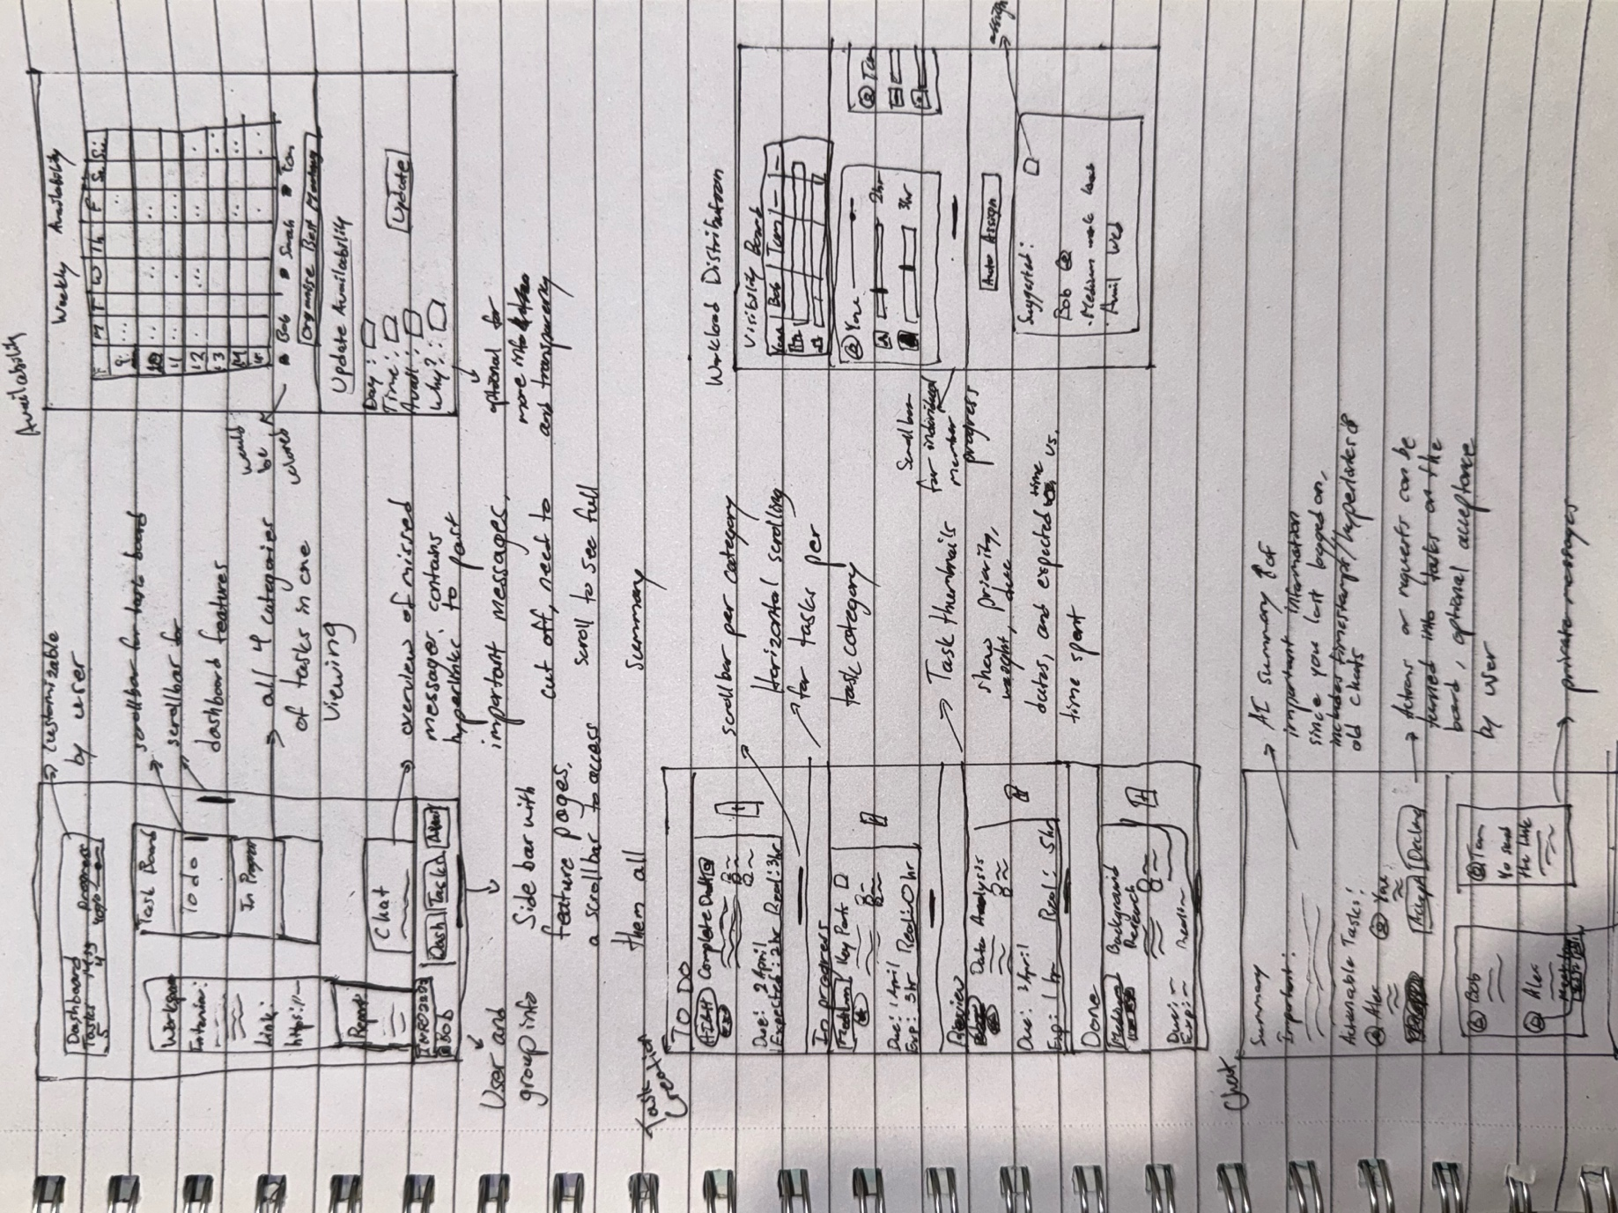
Figure 4: Vertical Paper Prototype

git reset --hard origin/main
We merged the best of the two designs together, collating the key features from both designs above in Task 2a. While the refined design ideas were generally more suited for our final product, there were still some key, fundamental designs in the initial ideas, such as the shared availability input and the workload visibility board, that we felt were necessary for our final design.

Our aim is to have a platform that has everything a university student may need, however, we still want to reduce visual clutter. Therefore, our prototype has several distinct feature pages that group together similar key features. For instance, the availability page which draws upon from both Figure 1 and Figure 2. There is also a high level of customizability to ensure user needs and requirements are met.

The horizontal and vertical paper prototypes are nearly identical, only with differing layouts. To accommodate for the screen orientation. The vertical prototype has more scroll bars in order to avoid visual clutter of information while still keeping key features all in one place.

The presented paper prototype goes quite in detail into the key functions and features that make the communication platform unique and valuable. There is not an extreme level of detail as many abbreviations and symbols are used to replace actual data or information, however, the overall objective of certain features are well represented.

[New Page]
Task 3-a
Include a few screenshots with captions, and describe the functionality of the first prototype. Explicitly outline the features that are working and not working.

Link to the prototype:
https://github.sydney.edu.au/INFO2222-2026-S1/PRJ-T02-G04/tree/main/feather-handdrawn-nextjs-project

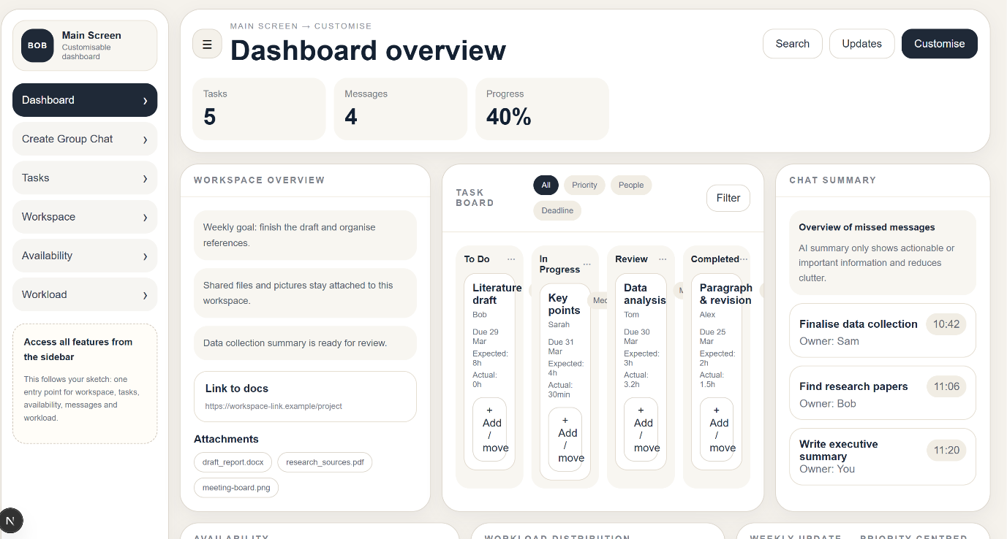
The dashboard will be the central hub where all application features integrate into a single interface:
A Kanban-style task board showing tasks in four stages: To Do, In Progress, Review, and Completed
A weekly availability feature showing team members’ schedules in a visual manner
A workload distribution feature showing team members’ balanced or overloaded workloads
A chat feature for team communication, both in groups and individually
A summary feature showing key updates using artificial intelligence
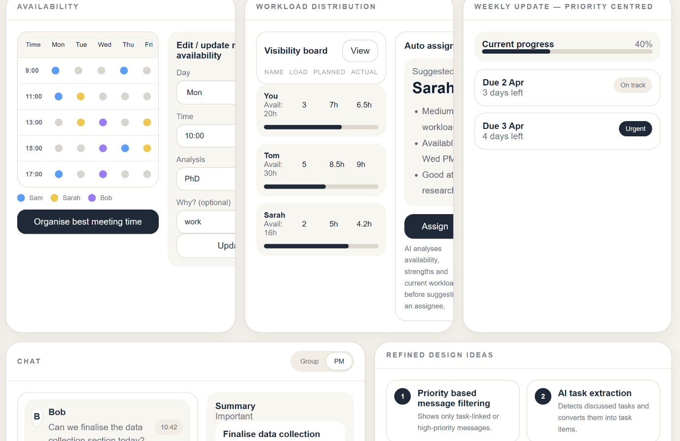
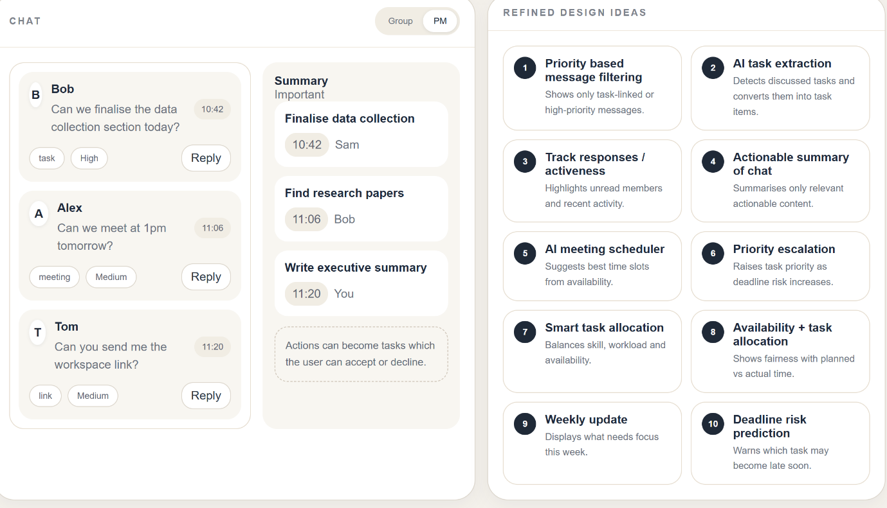

Aside from the solid visuals and structural aspects of design, there are a number of design elements that are not up and running yet.
No real backend logic has been incorporated into the prototype. Currently, you can create a task and enter data but those entries will not be saved nor will they be shown in real time on the task dashboard.
The Kanban board is also static; therefore, you are unable to drag tasks, make updates, or see those updates reflected immediately through real-time synchronization with the board.
The availability timetable lacks interactivity; therefore, you will not be able to save any of your changes to your team's availability, nor will updated availability be automatically aggregated and presented to you.
The chat system is non-functional and does not allow for real-time messaging; hence, there will be no capabilities for reactions or notifications at this time.
The AI summary is still an idea on paper and therefore does not produce actual summaries of messages.
Data integration is also missing. Workload calculations and task assignments, for example, will not be dynamically linked.

File Path | Description | AI Tool | Prompt Used
feather-handdrawn-nextjs-project | The Hi-Fi prototype | ChatGPT | Generate a website in Next.js format based on my draft drawing.

Table 1: Summary of AI-generated files and prompts used

Appendix A: Interview transcript

Interview a.

1. What tools do you currently use for group work?
For my group I currently use most for Google, Google Docs, and also, and also, IG group chat. I think I will use it group chat for immediately exchange our information and discuss and for Google Docs we added our work in a shared document.

2. How do you usually communicate with your group members?
Meaningful to share with some documents we may use. Also use email, and that's all.

3. What difficulties do you face when working in a group?
I think is something to deal with a timeline like we can share, we can set a due date and change it whenever we think it's possible. We think it's necessary. And also we were faced like we don't agree with each other, and we will provide with our proofs and also our evidence and also our point of point of view, and we want to talk about it and then come to an answer, and when keeping track of that, we don't think there is not a tool that can meet our need.

4. Can you describe a situation where group work did not go well?
Our group member just uploaded something and edited something in the shared document, but she forgot to tell us in the Instagram protest. So we all neglected and after we already uploaded into the homework, which one does? Oh, we added something here, which is not good enough. So I think maybe sometimes they check the history and help us to inform us about this. And yeah, that's that's all.

5. How are tasks assigned in your group? Is this effective?
We usually just use some simple things, like the task includes several stamps and people. Person one will be assigned with group one, with task one and two, and group and people two will assign with, will be assigned with task three and four. And if it's if something changed during our process, like the task the task three is really huge, and I come to do it with myself, and we will change it, and we will change it after talk with each other in group chat. So I don't think it's effective, effective enough, because when we're waiting for others to reply with our appointments, we will have nothing, nothing to do but wait.

6. Have you experienced communication issues? How did they affect your work?
I think, like I just mentioned in the last question.

7. What features would improve your group work experience?
I think, first of all is task management. Task management management, it will help us assign and for our working process, checking off our working process, and also the due date hand management things, right?

Interview b.

1. What tools do you currently use for group work?
Currently I use Microsoft Word, Excel and PowerPoint, and sometimes github for my group assignments.

2. How do you usually communicate with your group members?
Typical communication is through teams. However, a more accessible uh communication method can easily be through messages, WhatsApp or Instagram. �Um, I prefer messages, but then for easy accessibility for some group members, WhatsApp may be the more preferred option.

3. What difficulties do you face when working in a group?
The main difficulty is making sure everyone in the group is keeping up with their work and ensuring the overall group progress is proceeding as expected, but other than that, as long as communication is maintained well enough, most challenges should be overcomeable.

4. Can you describe a situation where group work did not go well?
Well, there was a situation where during one of my group projects, since there was a big group and there were a lot of tasks that needed to be distributed, but the tasks were not clearly distributed as to who was doing which part. Uh a difficulty was that one half of the group project was getting completed uh with a lot of progress, but the remaining report was left aside until I had to step up and allocate tasks for each team member to ensure every part of the project was completed and accounted for.

5. How are tasks assigned in your group? Is this effective?
Typically when tasks, when we are notified of each task, we break them down into different sections such as uh, if it was for engineering, you would have a mechanical system, electrical system, etcera. Uh, it would firstly be distributed based off each person's strengths and their likings. If there are no particular likings or strengths, it will then be distributed evenly across the group. By evenly I mean regarding the size of each task. If it has been determined that the task um requires more time, it may be distributed to two people, instead of one person and is typically just determined by the size of the task and the estimated time of completion required.

6. Have you experienced communication issues? How did they affect your work?
No, not really. I have been really lucky with all my groups so far. However, I have experienced some issues regarding the communication of quality and standards of project work. Um like during a big group report, as it was a um rather large-sized report, um each person was allocated different sections. However, um there was some sections that were not complete to the best standard or quality, so I had to recheck and ensure there was no errors including any grammatical and structural errors within the report. This meant that I was doing a bit more work then I expected.

7. What features would improve your group work experience?
Features that would improve my group work experience would be to have a timetable or like a open shared timetable that can be used to track everyone's progress, as well as know each person's availability so that we could um plan a regular group meeting time for each week and maintain consistent group meetings and checkups throughout the semester. And making sure that everyone in the team is able to like meet up and discuss the tasks.

Interview c.

1. What tools do you currently use for group work?
We use either WhatsApp or Instagram, mainly Instagram because it is more universally accessible and used. Google docs is also commonly used for collaborative work.

2. How do you usually communicate with your group members?
We mostly communicate through group chats on Instagram or try to have meetings in person. Group chats are good for progress updates and clearing up confusions or conflicts with the group work. However, private messages are more useful when your progress directly depends on someone else's. Too many direct messages in a group chat can clutter a group chat and impede on group progression.

3. What difficulties do you face when working in a group?
Communicating can be difficult when face to face with other people who don't enjoy talking. Group coordination can also be difficult if someone doesn't meet their responsibilities. Langauge barriers can be difficult. When working with AI, some will output different conclusions from the same prompts, resulting in a clash of information. When group members don't have the same level of standard, that can also be difficult. The main difficulty is ensuring everyone has even responsibilities and are meeting them in a timely manner as well.

4. Can you describe a situation where group work did not go well?
Some members didn't meet the same standard of work, meaning that during the final presentation, it was very evident that some members had detailed research and were able to speak on their respective parts but others weren't knowledgeable in their sections. It made the project overall seem disorganised. There were also communication errors and delays during the group work.

5. How are tasks assigned in your group? Is this effective?
It usually starts with one proactive person claiming some tasks for themselves, then people slowly allocating themselves their own tasks and balancing them all together as a group. The task distribution is typically fair in this manner as people get what they want and the weight of the responsibilities are balanced as a group. It typically is effective in motivating people to accomplish the tasks they want and reassuring that everyone has similar work loads. The only real issues come in people not following up with their assigned tasks.

6. Have you experienced communication issues? How did they affect your work?
Yes, sometimes too many individual or conversations between 2-3 people in a group chat can clutter the group and important details may be covered up. This requires others to be filled in later and confusions can occur. Also, sometimes a language barrier can disrupt effective group communication, making it dry or misunderstandings can occur.

7. What features would improve your group work experience?
Timestamps or completion markers to track individual or group progression. Chat boxes to use while working. Visual or attention grabbing stimuli. Some form of a task board with weighted tasks using points or a similar system. AI checking system. Timetabling for meetings or other activities.

Interview d.

1. What tools do you currently use for group work?
I use WhatsApp, Instagram, and sometimes Zoom.

2. How do you usually communicate with your group members?
We mostly communicate through group chats, and use Zoom for urgent issues.

3. What difficulties do you face when working in a group?
Slow responses delay following tasks.

4. Can you describe a situation where group work did not go well?
Some members did not respond for days, which caused an unbalanced workflow.

5. How are tasks assigned in your group? Is this effective?
Tasks are assigned informally through chat, which is not very effective because it takes time to get agreement from team members.

6. Have you experienced communication issues? How did they affect your work?
Yes, important alerts were buried under other messages and that caused confusion.

7. What features would improve your group work experience?
A system with tasks, chats and deadlines in one place.

[New Page]

Weekly Diary (Always use the name as it appears in Canvas):

Group Name
Week | Student Name | Activities
W04 | Seonghyun Kim | Planned out schedule and allocate works that team can do together.
W04 | Adam Li | Interview.
W04 | Jimu Li | Helped plan the rough timeline for tasks and conducted an interview.
W04 | Christina Liu | Conducted an interview and analysed some consistent themes.
W05 | Seonghyun Kim | Refined aim including interview format and worked on individual task.
W05 | Adam Li | Finished the user scenario; work on the hifi prototype.
W05 | Jimu Li | Aided in group discussions and continued with individual work on the project report.
W05 | Christina Liu | Worked on the group project, contributing ideas to additional features that align with data collected form interviews.
W06 | Seonghyun Kim | Explained our aim of project to solve several issues that were represented by interview during the demo.
W06 |  | Completed the 10 by 10 ideation designs and also the initial horizontal lofi design drawing. Explaining our design process and improvement during the demo as well.
W06 | Jimu Li | Spoke about the paper prototype during the demo. Proofread the report, ensuring consistency and accuracy. Also completed fixed up the horizontal and vertical drawings.
W06 | Adam Li | Work on the document.

Appendix A: All Consent Forms

Participant Information Statement

Research study: Title (adjust in File>Info>Properties>Title then right click here and select Update Field)

Christina Liu (Responsible Researcher)
Faculty of Engineering
Phone +61 2 0402628559 | Email: cliu0081@uni.sydney.edu.au
Seonghyun Kim (Advanced Computing student) | Email: skim0527@uni.sydney.edu.au, Adam Li (Advanced Computing student) | Email: zhli0710@ uni.sydney.edu.au, Jimu Li (Advanced Computing and Medical Science student) | Email: jili0060@uni.sydney.edu.au

What is this study about?
We are conducting a research study about the difficulties and challenges that students, particularly university students, are facing during group work projects. Taking part in this study is voluntary.
Please read this sheet carefully and ask questions about anything you don’t understand or want to know more about.

Who is running this study?
The study is being carried out by the following researchers:
- Christina Liu, Seonghyun Kim, Adam Li, Jimu Li. We are all university students under the Faculty of Engineering.
All students are conducting this study as a basis for a bachelor’s degree (Unit INFO2222) at the University of Sydney.
This study is not being funded.

Who can take part in the study?
We are seeking any student who has had experience working in a group project. There are no other criteria to participate.

What will the study involve for me?
If you decide to take part in this study, you will be asked to answer a list of 7 questions about your group project experience. Particularly focusing on any difficulties or challenges you have experienced. Your answers to all questions asked will be transcribed for future reference throughout the study. The interview itself will take no longer than 15 minutes but should be between 10-15 minutes. The interview will take place either in person or on zoom, depending on the participant’s availability. All the questions that will be asked will be open ended, all general questions about group work experience. Transcripts of the interview will be used for the research as well. But no other records of yours will be used. You may request access to review your transcript..

Can I withdraw once I have started?
Being in this study is completely voluntary and you do not have to take part.
Your decision will not affect your current or future relationship with the researchers or anyone else at The University of Sydney.
If you decide to take part in the study and then change your mind, you can withdraw by 2nd of April.
[Interviews]
If you take part in an interview you may refuse to answer any questions that you do not wish to answer.
[Where data can be omitted from study results]
If you choose to withdraw, we will stop collecting information from you. If you don’t want the information already collected to be in the study results, please tell us at the time you withdraw.

Are there any risks or costs?
No, there are no risks or costs involved.
Aside from giving up your time, we do not expect that there will be any risks or costs associated with taking part in this study.

Are there any benefits?
[No direct benefits expected]
You will not receive any direct benefits from being in the study.
Potential benefits for the wider community from this study would be the application/software created with results of this study in mind. It would hopefully benefit them by providing them a platform for group project work.

What will happen to information that is collected?
By providing your consent, you are agreeing to us collecting information from or about you for the purposes of this study.
Any identifiable information you provide us will be stored securely and will only be disclosed with your permission unless we are required by law to release information.
We plan to publish the study findings.
[Participants will not be identifiable]
You will not be individually identifiable in these publications.
No personal information will be collected from participants, only their answers to our interview questions will be retained and used. The INFO2222 teaching team would have access to the interview transcripts as well, but that will be the only data collected. No information will be transferred outside of Australia or shared to government agencies. Data will be kept until the end of the semester (01/06/2026).

[Transcription using software]
No transcription software will be used as transcription would happen manually during the meeting, as each interviewer will transcribe in real time on the notes application on macos.
We will store this information and dispose of it securely following the University’s Recordkeeping Policy. For more details about how your information will be handled please see the University’s privacy webpage.
[Secondary use of research data]
There are no plans on sharing any data to secondary parties.
Sharing research data is important for advancing knowledge and innovation. A de-identified set of the data collected in this study may be made available for use in future research.

Will I be told the results of the study?
You have the right to receive feedback about the overall results of this study. If you would like to receive feedback, please inform us at the end of the interview. This feedback will be in the form of verbal feedback.
There will be no personalised feedback provided unless requested.

What if I would like more information?
When you have read this information, the following researcher(s) will be available to discuss it with you further and answer any questions you may have:
- Christina Liu (Advanced Computing and Medical Science student) | Email: cliu0081@uni.sydney.edu.au, Seonghyun Kim (Advanced Computing student) | Email: skim0527@uni.sydney.edu.au, Adam Li (Advanced Computing student) | Email: zhli0710@ uni.sydney.edu.au, Jimu Li (Advanced Computing and Medical Science student) | Email: jili0060@uni.sydney.edu.au

What if I have a complaint or any concerns?
The ethical aspects of this study have been approved by the Human Research Ethics Committee (HREC) of The University of Sydney [ethics reference: insert ethics reference number] according to the National Statement on Ethical Conduct in Human Research.
If you are concerned about the way this study is being conducted or you wish to make a complaint to someone independent from the study, please contact the University:
Human Ethics Manager
human.ethics@sydney.edu.au
+61 2 8627 8176
Where applicable include an independent local complaints contact for research involving overseas participants (see Section 4.8.16 of the National Statement). This should include their name, position, and contact details.

This information sheet is for you to keep

Participant Consent Form
Where relevant, specify your participant group here (i.e., if you have more than one group and you need separate forms with custom information for each). Remove this field if not relevant.

Research study: Title (adjust in File>Info>Properties>Title then right click here and select Update Field)

Adam Li (Responsible Researcher)
Faculty of Engineering
Phone +610447041757 | Email: zhli0710@uni.sydney.edu.au
Seonghyun Kim (Advanced Computing student) | Email: skim0527@uni.sydney.edu.au, Adam Li (Advanced Computing student) | Email: zhli0710@ uni.sydney.edu.au, Jimu Li (Advanced Computing and Medical Science student) | Email: jili0060@uni.sydney.edu.au

Participant Name | Holly Wu

I agree to take part in this research study. In giving my consent, I confirm that that:

- The details of my involvement have been explained to me, and I have been provided with a written Participant Information Statement to keep.

- I understand the purpose of the study is to investigate the experiences of students in group work.

- I acknowledge that the risks and benefits of participating in this study have been explained to me to my satisfaction.

- I understand that in this study I will be required to answer interview questions based on personal experiences.

- I understand that participation involves a transcript of interview responses.

- I understand that being in this study is completely voluntary.

- I am assured that my decision to participate will not have any impact on my relationship with the research team or the University of Sydney.

- I understand that I am free to withdraw from this study at any time and that I can choose to withdraw any information I have already provided (unless the data has already been de-identified or published).

- I have been informed that the confidentiality of the information I provide will be protected and will only be used for purposes that I have agreed to. I understand that information identifying me will only be told to others with my permission, except as required by law.

- [Where participants will not be identified] I understand that the results of this study may be published, and that publications will not contain my name or any identifiable information about me.

[Where participants may be identified] I understand that the results of this study may be published. Although every effort will be made to protect my identity, I may be identifiable in these publications due to the nature of the study or results.

[Where participants can choose to be identified] I understand that the results of this study may be published, but these publications will not contain my name or any identifiable information about me unless I consent to being identified using the ‘Yes’ checkbox below.

☐Yes, I am happy to be identified

☒ No, I do not want to be identified. Please keep my identity confidential.

[Where participants will be identified] I understand that the results of this study may be published, and that I will be identified in these publications.

The section below is intended for participants to provide consent to specific components of your study that are not mandatory for participation. Insert the following only where applicable to your study. You may like to add checkboxes for additional aspects of your study that are optional (e.g., contacting a participant to clarify responses, invite them to further interview, provide personalised results etc).

- I confirm the following:
I consent to recordings (audio) | Yes ☒ No ☐
I consent to accessing my records (specify existing data) | Yes ☐ No ☒
I would like to review my interview transcripts | Yes ☐ No ☒
I consent to being contacted for future studies | Yes ☐ No ☒
I consent to my data being used in future research | Yes ☐ No ☒
I would like feedback on the overall results of this study | Yes ☐ No ☒

If you answered yes to receiving feedback or being contacted in future, please provide your preferred contact details (email/telephone/postal address):

- I understand that after I sign and return this consent form it will be retained by the researcher, and that I may request a copy at any time.

Participant Name | Holly Wu
Signature | Holly Wu
Date | 25/03/2026

Participant Consent Form
Where relevant, specify your participant group here (i.e., if you have more than one group and you need separate forms with custom information for each). Remove this field if not relevant.

Research study: Title (adjust in File>Info>Properties>Title then right click here and select Update Field)

Christina Liu (Responsible Researcher)
Faculty of Engineering
Phone +61 2 0402628559 | Email: cliu0081@uni.sydney.edu.au
Seonghyun Kim (Advanced Computing student) | Email: skim0527@uni.sydney.edu.au, Adam Li (Advanced Computing student) | Email: zhli0710@ uni.sydney.edu.au, Jimu Li (Advanced Computing and Medical Science student) | Email: jili0060@uni.sydney.edu.au

Participant Name | Jade Zhou

I agree to take part in this research study. In giving my consent, I confirm that that:

- The details of my involvement have been explained to me, and I have been provided with a written Participant Information Statement to keep.

- I understand the purpose of the study is to investigate the experiences of students in group work.

- I acknowledge that the risks and benefits of participating in this study have been explained to me to my satisfaction.

- I understand that in this study I will be required to answer interview questions based on personal experiences.

- I understand that participation involves a transcript of interview responses.

- I understand that being in this study is completely voluntary.

- I am assured that my decision to participate will not have any impact on my relationship with the research team or the University of Sydney.

- I understand that I am free to withdraw from this study at any time and that I can choose to withdraw any information I have already provided (unless the data has already been de-identified or published).

- I have been informed that the confidentiality of the information I provide will be protected and will only be used for purposes that I have agreed to. I understand that information identifying me will only be told to others with my permission, except as required by law.

- [Where participants will not be identified] I understand that the results of this study may be published, and that publications will not contain my name or any identifiable information about me.

[Where participants may be identified] I understand that the results of this study may be published. Although every effort will be made to protect my identity, I may be identifiable in these publications due to the nature of the study or results.

[Where participants can choose to be identified] I understand that the results of this study may be published, but these publications will not contain my name or any identifiable information about me unless I consent to being identified using the ‘Yes’ checkbox below.

☐Yes, I am happy to be identified

☒ No, I do not want to be identified. Please keep my identity confidential.

[Where participants will be identified] I understand that the results of this study may be published, and that I will be identified in these publications.

The section below is intended for participants to provide consent to specific components of your study that are not mandatory for participation. Insert the following only where applicable to your study. You may like to add checkboxes for additional aspects of your study that are optional (e.g., contacting a participant to clarify responses, invite them to further interview, provide personalised results etc).

- I confirm the following:
I consent to recordings (audio) | Yes ☒ No ☐
I consent to accessing my records (specify existing data) | Yes ☐ No ☒
I would like to review my interview transcripts | Yes ☐ No ☒
I consent to being contacted for future studies | Yes ☐ No ☒
I consent to my data being used in future research | Yes ☐ No ☒
I would like feedback on the overall results of this study | Yes ☐ No ☒

If you answered yes to receiving feedback or being contacted in future, please provide your preferred contact details (email/telephone/postal address):

- I understand that after I sign and return this consent form it will be retained by the researcher, and that I may request a copy at any time.

Participant Name | Jade Zhou
Signature
Date | 30/03/2026

Participant Consent Form
Where relevant, specify your participant group here (i.e., if you have more than one group and you need separate forms with custom information for each). Remove this field if not relevant.

Research study: Title (adjust in File>Info>Properties>Title then right click here and select Update Field)

Christina Liu (Responsible Researcher)
Faculty of Engineering
Phone +61 2 0402628559 | Email: cliu0081@uni.sydney.edu.au
Seonghyun Kim (Advanced Computing student) | Email: skim0527@uni.sydney.edu.au, Adam Li (Advanced Computing student) | Email: zhli0710@ uni.sydney.edu.au, Jimu Li (Advanced Computing and Medical Science student) | Email: jili0060@uni.sydney.edu.au

Participant Name | Jidu Li

I agree to take part in this research study. In giving my consent, I confirm that that:

- The details of my involvement have been explained to me, and I have been provided with a written Participant Information Statement to keep.

- I understand the purpose of the study is to investigate insert one sentence description.

- I acknowledge that the risks and benefits of participating in this study have been explained to me to my satisfaction.

- I understand that in this study I will be required to insert each activity the participant will undertake in the project. Ensure that this is consistent with the information provided in the Participant Information Statement.

- I understand that participation involves indicate specific recordings or requirements e.g., audio and/or video-recordings, photographs, eye tracking, location tracking, access to existing records. If not relevant remove paragraph.

- I understand that if I provide consent my information may be used in future research where relevant insert details about the extended consent sought e.g., type of research activity or proposed data sharing. If not relevant remove paragraph.

- I understand that being in this study is completely voluntary.

- I am assured that my decision to participate will not have any impact on my relationship with the research team or the University of Sydney insert any other party to which this assurance is relevant and true.

- I understand that I am free to withdraw from this study at any time and that I can choose to withdraw any information I have already provided (unless the data has already been de-identified or published).

- I have been informed that the confidentiality of the information I provide will be protected and will only be used for purposes that I have agreed to. I understand that information identifying me will only be told to others with my permission, except as required by law.

- [Where participants will not be identified] I understand that the results of this study may be published, and that publications will not contain my name or any identifiable information about me.

[Where participants may be identified] I understand that the results of this study may be published. Although every effort will be made to protect my identity, I may be identifiable in these publications due to the nature of the study or results.

[Where participants can choose to be identified] I understand that the results of this study may be published, but these publications will not contain my name or any identifiable information about me unless I consent to being identified using the ‘Yes’ checkbox below.

☐Yes, I am happy to be identified

☒ No, I do not want to be identified. Please keep my identity confidential.

[Where participants will be identified] I understand that the results of this study may be published, and that I will be identified in these publications.

The section below is intended for participants to provide consent to specific components of your study that are not mandatory for participation. Insert the following only where applicable to your study. You may like to add checkboxes for additional aspects of your study that are optional (e.g., contacting a participant to clarify responses, invite them to further interview, provide personalised results etc).

- I confirm the following:
I consent to recordings (specify e.g., audio/video/photographic) | Yes ☒ No ☐
I consent to accessing my records (specify existing data) | Yes ☐ No ☒
I would like to review my interview transcripts | Yes ☐ No ☒
I consent to being contacted for future studies | Yes ☒ No ☐
I consent to my data being used in future research | Yes ☐ No ☒
I would like feedback on the overall results of this study | Yes ☐ No ☒

If you answered yes to receiving feedback or being contacted in future, please provide your preferred contact details (email/telephone/postal address):

- I understand that after I sign and return this consent form it will be retained by the researcher, and that I may request a copy at any time.

Participant Name | Jidu Li
Signature
Date | 25/03/2026

Participant Consent Form
Where relevant, specify your participant group here (i.e., if you have more than one group and you need separate forms with custom information for each). Remove this field if not relevant.

Research study: Title (adjust in File>Info>Properties>Title then right click here and select Update Field)

Christina Liu (Responsible Researcher)
Faculty of Engineering
Phone +61 2 0402628559 | Email: cliu0081@uni.sydney.edu.au
Seonghyun Kim (Advanced Computing student) | Email: skim0527@uni.sydney.edu.au, Adam Li (Advanced Computing student) | Email: zhli0710@ uni.sydney.edu.au, Jimu Li (Advanced Computing and Medical Science student) | Email: jili0060@uni.sydney.edu.au

Participant Name | Lucy Jang

I agree to take part in this research study. In giving my consent, I confirm that that:

- The details of my involvement have been explained to me, and I have been provided with a written Participant Information Statement to keep.

- I understand the purpose of the study is to investigate the experiences of students in group work.

- I acknowledge that the risks and benefits of participating in this study have been explained to me to my satisfaction.

- I understand that in this study I will be required to answer interview questions based on personal experiences.

- I understand that participation involves a transcript of interview responses.

- I understand that being in this study is completely voluntary.

- I am assured that my decision to participate will not have any impact on my relationship with the research team or the University of Sydney.

- I understand that I am free to withdraw from this study at any time and that I can choose to withdraw any information I have already provided (unless the data has already been de-identified or published).

- I have been informed that the confidentiality of the information I provide will be protected and will only be used for purposes that I have agreed to. I understand that information identifying me will only be told to others with my permission, except as required by law.

- [Where participants will not be identified] I understand that the results of this study may be published, and that publications will not contain my name or any identifiable information about me.

[Where participants may be identified] I understand that the results of this study may be published. Although every effort will be made to protect my identity, I may be identifiable in these publications due to the nature of the study or results.

[Where participants can choose to be identified] I understand that the results of this study may be published, but these publications will not contain my name or any identifiable information about me unless I consent to being identified using the ‘Yes’ checkbox below.

☐Yes, I am happy to be identified

☒ No, I do not want to be identified. Please keep my identity confidential.

[Where participants will be identified] I understand that the results of this study may be published, and that I will be identified in these publications.

The section below is intended for participants to provide consent to specific components of your study that are not mandatory for participation. Insert the following only where applicable to your study. You may like to add checkboxes for additional aspects of your study that are optional (e.g., contacting a participant to clarify responses, invite them to further interview, provide personalised results etc).

- I confirm the following:
I consent to recordings (audio) | Yes ☒ No ☐
I consent to accessing my records (specify existing data) | Yes ☐ No ☒
I would like to review my interview transcripts | Yes ☐ No ☒
I consent to being contacted for future studies | Yes ☐ No ☒
I consent to my data being used in future research | Yes ☐ No ☒
I would like feedback on the overall results of this study | Yes ☐ No ☒

If you answered yes to receiving feedback or being contacted in future, please provide your preferred contact details (email/telephone/postal address):

- I understand that after I sign and return this consent form it will be retained by the researcher, and that I may request a copy at any time.

Participant Name | Lucy Jang
Signature | Lucy Jang
Date | 27/03/2026

Appendix B: Interview transcript

Interview a.

1. What tools do you currently use for group work?
For my group I currently use most for Google, Google Docs, and also, and also, IG group chat. I think I will use it group chat for immediately exchange our information and discuss and for Google Docs we added our work in a shared document.

2. How do you usually communicate with your group members?
Meaningful to share with some documents we may use. Also use email, and that's all.

3. What difficulties do you face when working in a group?
I think is something to deal with a timeline like we can share, we can set a due date and change it whenever we think it's possible. We think it's necessary. And also we were faced like we don't agree with each other, and we will provide with our proofs and also our evidence and also our point of point of view, and we want to talk about it and then come to an answer, and when keeping track of that, we don't think there is not a tool that can meet our need.

4. Can you describe a situation where group work did not go well?
Our group member just uploaded something and edited something in the shared document, but she forgot to tell us in the Instagram protest. So we all neglected and after we already uploaded into the homework, which one does? Oh, we added something here, which is not good enough. So I think maybe sometimes they check the history and help us to inform us about this. And yeah, that's that's all.

5. How are tasks assigned in your group? Is this effective?
We usually just use some simple things, like the task includes several stamps and people. Person one will be assigned with group one, with task one and two, and group and people two will assign with, will be assigned with task three and four. And if it's if something changed during our process, like the task the task three is really huge, and I come to do it with myself, and we will change it, and we will change it after talk with each other in group chat. So I don't think it's effective, effective enough, because when we're waiting for others to reply with our appointments, we will have nothing, nothing to do but wait.

6. Have you experienced communication issues? How did they affect your work?
I think, like I just mentioned in the last question.

7. What features would improve your group work experience?
I think, first of all is task management. Task management management, it will help us assign and for our working process, checking off our working process, and also the due date hand management things, right?

Interview b.

1. What tools do you currently use for group work?
Currently I use Microsoft Word, Excel and PowerPoint, and sometimes github for my group assignments.

2. How do you usually communicate with your group members?
Typical communication is through teams. However, a more accessible uh communication method can easily be through messages, WhatsApp or Instagram. �Um, I prefer messages, but then for easy accessibility for some group members, WhatsApp may be the more preferred option.

3. What difficulties do you face when working in a group?
The main difficulty is making sure everyone in the group is keeping up with their work and ensuring the overall group progress is proceeding as expected, but other than that, as long as communication is maintained well enough, most challenges should be overcomeable.

4. Can you describe a situation where group work did not go well?
Well, there was a situation where during one of my group projects, since there was a big group and there were a lot of tasks that needed to be distributed, but the tasks were not clearly distributed as to who was doing which part. Uh a difficulty was that one half of the group project was getting completed uh with a lot of progress, but the remaining report was left aside until I had to step up and allocate tasks for each team member to ensure every part of the project was completed and accounted for.

5. How are tasks assigned in your group? Is this effective?
Typically when tasks, when we are notified of each task, we break them down into different sections such as uh, if it was for engineering, you would have a mechanical system, electrical system, etcera. Uh, it would firstly be distributed based off each person's strengths and their likings. If there are no particular likings or strengths, it will then be distributed evenly across the group. By evenly I mean regarding the size of each task. If it has been determined that the task um requires more time, it may be distributed to two people, instead of one person and is typically just determined by the size of the task and the estimated time of completion required.

6. Have you experienced communication issues? How did they affect your work?
No, not really. I have been really lucky with all my groups so far. However, I have experienced some issues regarding the communication of quality and standards of project work. Um like during a big group report, as it was a um rather large-sized report, um each person was allocated different sections. However, um there was some sections that were not complete to the best standard or quality, so I had to recheck and ensure there was no errors including any grammatical and structural errors within the report. This meant that I was doing a bit more work then I expected.

7. What features would improve your group work experience?
Features that would improve my group work experience would be to have a timetable or like a open shared timetable that can be used to track everyone's progress, as well as know each person's availability so that we could um plan a regular group meeting time for each week and maintain consistent group meetings and checkups throughout the semester. And making sure that everyone in the team is able to like meet up and discuss the tasks.

Interview c.

1. What tools do you currently use for group work?
We use either WhatsApp or Instagram, mainly Instagram because it is more universally accessible and used. Google docs is also commonly used for collaborative work.

2. How do you usually communicate with your group members?
We mostly communicate through group chats on Instagram or try to have meetings in person. Group chats are good for progress updates and clearing up confusions or conflicts with the group work. However, private messages are more useful when your progress directly depends on someone else's. Too many direct messages in a group chat can clutter a group chat and impede on group progression.

3. What difficulties do you face when working in a group?
Communicating can be difficult when face to face with other people who don't enjoy talking. Group coordination can also be difficult if someone doesn't meet their responsibilities. Langauge barriers can be difficult. When working with AI, some will output different conclusions from the same prompts, resulting in a clash of information. When group members don't have the same level of standard, that can also be difficult. The main difficulty is ensuring everyone has even responsibilities and are meeting them in a timely manner as well.

4. Can you describe a situation where group work did not go well?
Some members didn't meet the same standard of work, meaning that during the final presentation, it was very evident that some members had detailed research and were able to speak on their respective parts but others weren't knowledgeable in their sections. It made the project overall seem disorganised. There were also communication errors and delays during the group work.

5. How are tasks assigned in your group? Is this effective?
It usually starts with one proactive person claiming some tasks for themselves, then people slowly allocating themselves their own tasks and balancing them all together as a group. The task distribution is typically fair in this manner as people get what they want and the weight of the responsibilities are balanced as a group. It typically is effective in motivating people to accomplish the tasks they want and reassuring that everyone has similar work loads. The only real issues come in people not following up with their assigned tasks.

6. Have you experienced communication issues? How did they affect your work?
Yes, sometimes too many individual or conversations between 2-3 people in a group chat can clutter the group and important details may be covered up. This requires others to be filled in later and confusions can occur. Also, sometimes a language barrier can disrupt effective group communication, making it dry or misunderstandings can occur.

7. What features would improve your group work experience?
Timestamps or completion markers to track individual or group progression. Chat boxes to use while working. Visual or attention grabbing stimuli. Some form of a task board with weighted tasks using points or a similar system. AI checking system. Timetabling for meetings or other activities.

Interview d.

1. What tools do you currently use for group work?
I use WhatsApp, Instagram, and sometimes Zoom.

2. How do you usually communicate with your group members?
We mostly communicate through group chats, and use Zoom for urgent issues.

3. What difficulties do you face when working in a group?
Slow responses delay following tasks.

4. Can you describe a situation where group work did not go well?
Some members did not respond for days, which caused an unbalanced workflow.

5. How are tasks assigned in your group? Is this effective?
Tasks are assigned informally through chat, which is not very effective because it takes time to get agreement from team members.

6. Have you experienced communication issues? How did they affect your work?
Yes, important alerts were buried under other messages and that caused confusion.

7. What features would improve your group work experience?
A system with tasks, chats and deadlines in one place.

